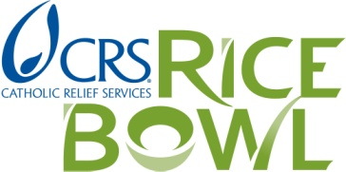

To: 2016 Rice Bowl Grant Recipients

Re: Report on use of 2016 Rice Bowl Grant Funds – Deadline date: May 19, 2017

The 2016 Guidelines for Catholic Relief Services RICE BOWL grant applications stated that organizations receiving grants needed to submit a simple written report.

We ask that you please submit your report using the following Report Form for Use of 2016 Grant Funds, explaining how the money was used and the approximate number of persons served through the grant.

Please note that 2017 grant requests from your parish or organization may not be considered if this report is not returned. If you are not applying for a 2017 Rice Bowl grant, we still need to have a report from your organization.

Thank you!

Report Form: use of 2016 Rice Bowl grant funds
Deadline: May 19, 2017

Center for Mission
777 Forest Street
Saint Paul, MN 55106
(651) 291-4504
Email: haaslm@archspm.org

Name of Parish, School or Organization:

Name of Program or Project (if different from above):

Mailing Address:

City: Zip: Daytime Phone: ( )

Contact Person: Position/Title:

E-Mail Address:

Person making report if not Contact Person: E-mail:

Website Address (if you have one):

1. How did you use the Catholic Relief Services RICE BOWL grant?
Ex: “Funds from the 2016 grant were used to purchase protein and infant formula

- Approximately how many people did your group serve in the last year?
Ex: “We estimate 75 households received grocery store vouchers.”

3. Please feel free to include photos or stories with this report, by e-mail or mail, that could be used in our publicity, with your permission.

