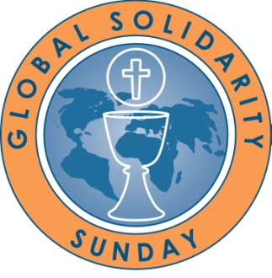
Global Solidarity Sunday
Collection Report Form

Due by: June 07, 2019

Parish: _______________________________________

City: _______________________________________

$ _____________ was our parish’s financial offering on Global Solidarity Sunday, March 31, 2019.

Please make check payable to and mail to:

Center for Mission
777 Forest Street
St. Paul, MN 55106 - 3857

Envelopes:
If you ordered envelopes from us and you would like to change your envelope order for 2020, please do so below. Otherwise, you will receive the same amount as the previous year.

I would like to order _____envelopes for 2020

Note: our envelopes are NOT dated so leftovers can be reused from year to year.
If your parishioners receive contribution envelopes, please add Global Solidarity Sunday to the packet.
Questions? Contact Bonnie Curry-Gabel, curry-gabelb@archspm.org, 651.291.4451.

Thank You!

