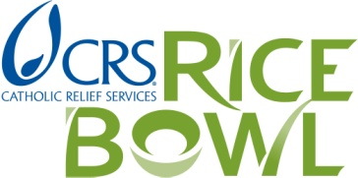

To: 2018 Rice Bowl Grant Recipients

Re: Report on use of 2018 Rice Bowl Grant Funds – Deadline date: July 1, 2019

The Criteria and Guidelines for Catholic Relief Services Rice Bowl Local Grant applications stated that all parishes and organizations receiving grants need to submit a simple written report.

We ask that you please submit your report using the following Report Form for Use of 2018 Grant Funds, explaining how the money was used and the approximate number of persons served with the grant.

Please note that 2019 grant requests from your parish or organization may not be considered if this report is not returned. Even if you are not applying for a 2019 Rice Bowl grant, we still need to have a report from your organization.

For your convenience, we have three form options for you to use: Word fill-in form, PDF fill-in form, PDF to be handwritten. Please save one of these options to your computer, fill it out, and return the completed form. This is the Word form.

Thank you!

Report Form: Use of 2018 Rice Bowl Grant Funds
Deadline: July 1, 2019

Center for Mission
Archdiocese of Saint Paul and Minneapolis
777 Forest Street
Saint Paul, MN 55106
(651) 291-4410
Email: mailto:fitzpatricka@archspm.org or currygabelb@archspm.org

Name of Parish, School or Organization: Click here.

Name of Program or Project (if different from above) Click here

Mailing Address:Click here.

City:Click here Zip:Click Daytime Phone: ( __)____ -

Contact Person: Click Here Position/Title: Click or tap here .

E-Mail: Click here

Person making report if not Contact Person:Click here

E-mail: Click here

Website Address (if you have one: Click here

1. How did you use the Catholic Relief Services RICE BOWL grant?
E.g., “Funds from the 2017 grant were used to purchase protein and infant formula…”
Click or tap here to enter text.

- Approximately how many people did your group serve in the last year?
Ex: “We estimate 75 households received grocery store vouchers.”
Click or tap here to enter text.

3. Please feel free to include photos or stories with this report and e-mail or mail to us. Photos and stories may be used in our publicity with your permission.

