RE: 2022 Missionary Cooperation Plan

Dear Applicant,

I received your request to be considered for our Missionary Cooperation Plan for the year 2022. Thank you for your interest in making mission appeals in the Archdiocese of St. Paul and Minneapolis, Minnesota.

Please complete the attached Missionary Cooperation Plan application form by opening the Word document, saving it to your desktop and typing right into the form and return it to this office via regular mail or email by December 1, 2021. Those mission groups accepted to make mission appeals will be notified by February 2022. As a future note, applications can also be found on our website: www.centerformission.org at the Downloads page.

Thank you for your commitment to proclaiming the Gospel through word and deed in your part of the world.

Sincerely,
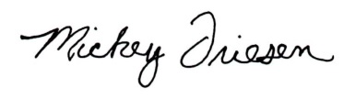
Deacon Mickey Friesen, D.Min.
Archdiocesan Director

Center for Mission
777 Forest Street
St. Paul, MN 55106
Phone: 651-291-4445
Email: friesenm@archspm.org
www.centerformission.org

