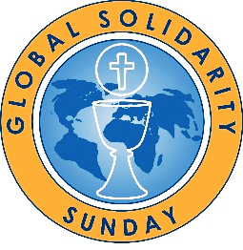
“For God so loved the world...”

Global Solidarity Sunday
March 9-10, 2024

Sample Bulletin Announcements

March 2/3, 2024
Global Solidarity Sunday Weekend: March 9-10
Next weekend, March 9-10, we observe Global Solidarity Sunday with the theme “For God so loved the world…” (Jn 3:16). This theme invites everyone to reach out, around the world, to share the love of Jesus Christ with those who hunger and thirst for God’s mercy, love, and healing. There is a special need today as the Church in Central and Eastern Europe, one of the GSS collections, is suffering the ravages of armed conflict. Global Solidarity Sunday also supports the spiritual, and material needs of three other global priorities of the U.S. Catholic Bishops: Africa, Latin America, and humanitarian activities of Catholic Relief Services. We ask you to be as generous as possible in sharing God’s love for your brothers and sisters around the world. Thank you.

March 9/10, 2024
Global Solidarity Sunday
Global Solidarity Sunday is an opportunity to contemplate John 3:16 “For God so loved the world…” You are invited to actively share God’s love as a sign of solidarity with your brothers and sisters throughout the world. We are all called to share gifts of financial support, an expression of Lenten almsgiving, by contributing to this collection for four global initiatives designated by the U.S. Catholic Bishops: The Church in Central and Eastern Europe, Africa, Latin America, as well as humanitarian activities of Catholic Relief Services. What is God calling you to share with your brothers and sisters in Christ?

March 30/31, 2024
Thank you!
On March 9/10, we collected $_______ for our Global Solidarity Sunday collection. Your brothers and sisters in Africa, Latin America, Central and Eastern Europe, and all those who receive much needed assistance through Catholic Relief Services thank you for your support and generosity.

