Dear Pastor/Administrator,

This year, we mark the annual **World Mission Sunday Celebration** on the weekend of October 19/20**.** We join with Catholics around the world to pray and offer our support for the missionary life of the Church. It also gives us the opportunity to renew our own missionary call according to our own state in life.

This year’s theme is, **“Go and invite everyone to the banquet” (Mt. 22:9).**  Pope Francis asks us to consider the missionary call as one of going out again and again to invite people to the feast of encountering God and entering communion with him. In every Eucharist, we are sent forth to love and serve the Lord. We each have a share in the Church’s universal mission and communion with all those bringing Christ to the ends of the earth.

This World Mission Sunday gives us a chance to learn about the mission church today and consider how we can participate in and support the Church’s evangelizing mission. We have the opportunity to reach beyond ourselves and beyond our borders to embrace God’s mission around the world.

I offer you the enclosed materials to enhance your World Mission Sunday celebration and support of efforts of more than 1,100 mission dioceses in over 100 countries. These materials and more are located on our Website for your use at [www.centerformission.org/downloads](http://www.centerformission.org/downloads). **Thank you for all you will do to prepare your parish for the fullest celebration of World Mission Sunday.**

May you be blessed in your ministry to serve God’s mission of Love to the world.

Sincerely in Christ,

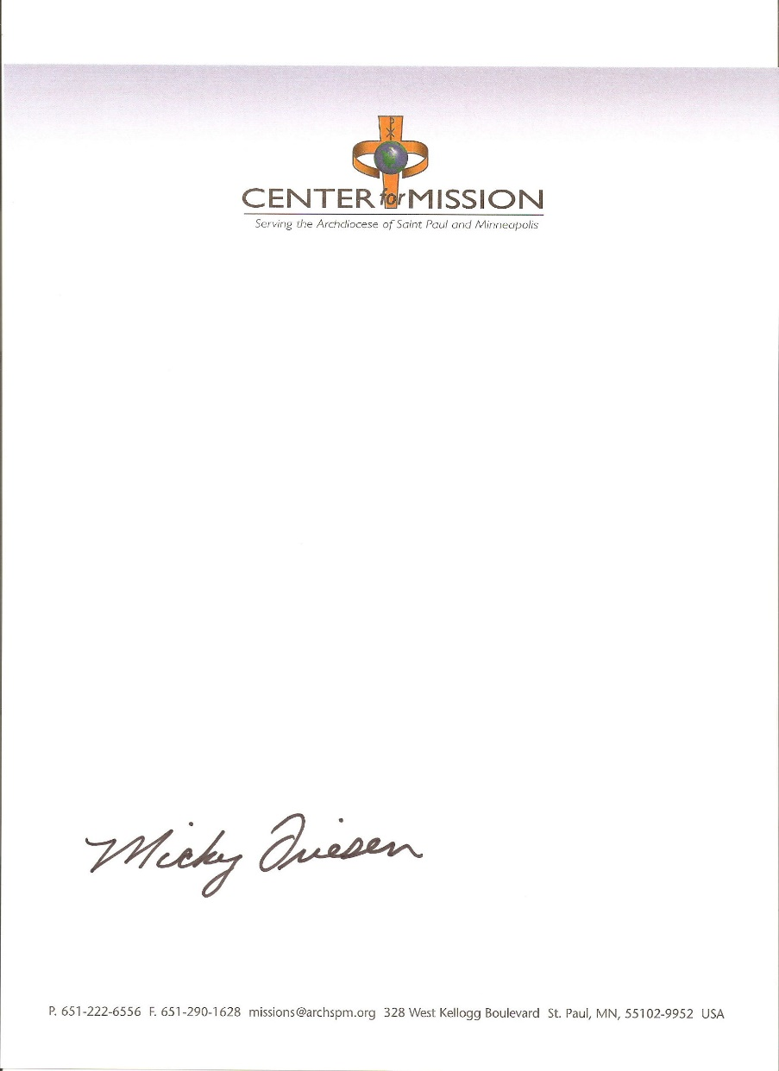

Deacon Mickey Friesen

Director