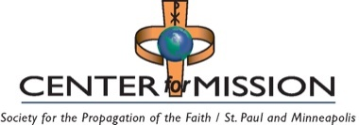 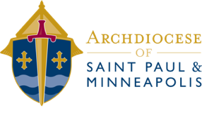

National and International Collections for 2025

# Remit to the CENTER FOR MISSION

Checks Payable to: **Center for Mission**

Mail to: Center for Mission, 777 Forest St., St. Paul, MN 55106-3857

|  |  |  |
| --- | --- | --- |
| **Collection Date** | **Collection** | **Remit Date** |
| March 5-April 20, 2025 | CRS Rice Bowl | August 29, 2025 |
| March 29-30, 2025 | Global Solidarity Sunday | July 31, 2025 |
| March–September, 2025 | Missionary Cooperation Plan | October 31, 2025 |
| April 18, 2025 | Holy Land Collection | August 29, 2025 |
| April 26-27, 2025 | Catholic Home Mission | August 29, 2025 |
| June 28-29, 2025 | Peter's Pence | October 31, 2025 |
| October 18-19, 2025 | World Mission Sunday | February 27, 2026 |
| November 15-16, 2025 | Campaign for Human Development | March 31, 2026 |

**NOTE:** If you are submitting disbursements for more than one collection, you may send one check. Please clearly note the specific designation for each collection on the check stub memo lines. Any questions, call Kim Williams at: 651-291-4451 or williamsk@archspm.org.

# Remit to the ARCHDIOCESE OF SAINT PAUL AND MINNEAPOLIS

Checks Payable to: **Archdiocese of Saint Paul and Minneapolis**

Mail to: Archdiocese of Saint Paul and Minneapolis, Accounting Office  
 777 Forest St., St. Paul, MN 55106-3857

|  |  |  |
| --- | --- | --- |
| **Collection Date** | **Collection** | **Remit Date** |
| November 8-9, 2025 | Military Services | March 31, 2026 |
| December 14-15, 2025 | Retirement Fund for Religious | April 30, 2026 |