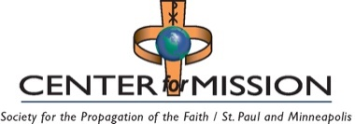 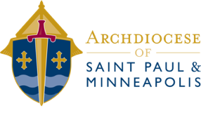

National and International Collections for 2026

# Remit to the CENTER FOR MISSION

Checks Payable to: **Center for Mission**

Mail to: Center for Mission, 777 Forest St., St. Paul, MN 55106-3857

|  |  |  |
| --- | --- | --- |
| **Collection Date** | **Collection** | **Remit Date** |
| Feb 18 – Apr 2 | CRS Rice Bowl | August 28, 2026 |
| March 14-15 | Global Solidarity Sunday | July 31, 2026 |
| March - September | Missionary Cooperation Plan | October 31, 2026 |
| April 3 | Holy Land Collection | August 28, 2026 |
| April 25-26 | Catholic Home Mission | August 28, 2026 |
| June 27-28 | Peter's Pence | October 30, 2026 |
| October 17-18 | World Mission Sunday | February 26, 2027 |
| November 14-15 | Campaign for Human Development | March 31, 2027 |

**NOTE:** If you are submitting disbursements for more than one collection, you may send one check. Please clearly note the specific designation for each collection on the check stub memo lines. Any questions, call Kim Williams at: 651-291-4451 or williamsk@archspm.org.

# Remit to the ARCHDIOCESE OF SAINT PAUL AND MINNEAPOLIS

Checks Payable to: **Archdiocese of Saint Paul and Minneapolis**

Mail to: Archdiocese of Saint Paul and Minneapolis, Accounting Office  
 777 Forest St., St. Paul, MN 55106-3857

|  |  |  |
| --- | --- | --- |
| **Collection Date** | **Collection** | **Remit Date** |
| December 12-12 | Retirement Fund for Religious |  |