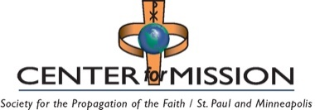 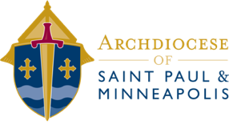

National and International

2025 Appeals

# Remit to the CENTER FOR MISSION

Checks Payable to: **Center for Mission**

Mail to: Center for Mission, 777 Forest St., St. Paul, MN 55106-3857

|  |  |  |
| --- | --- | --- |
| **Collection Date** | **Collection** | **Remit Date** |
| March 5-April 20 | CRS Rice Bowl | June 20, 2025 |
| March 29-30 | Global Solidarity Sunday | May 30, 2025 |
| March - September | Missionary Cooperation Plan | 60 days after speaker |
| April 18 | Holy Land Collection | June 17, 2025 |
| April 26-27 | Catholic Home Mission | June 27, 2025 |
| June 28-29 | Peter's Pence | August 29, 2025 |
| October 18-19 | World Mission Sunday | December 19, 2025 |
| November 15-16 | Campaign for Human Development | January 16, 2026 |

**NOTE:** If you are submitting disbursements for more than one collection, you may send one check. Please clearly note the specific designation for each collection on the check stub memo lines. Any questions, call Kim Williams at: 651-291-4451 or williamsk@archspm.org.

# Remit to the ARCHDIOCESE OF SAINT PAUL AND MINNEAPOLIS

Checks Payable to: **Archdiocese of Saint Paul and Minneapolis**

Mail to: Archdiocese of Saint Paul and Minneapolis, Accounting Office  
 777 Forest St., St. Paul, MN 55106-3857

|  |  |  |
| --- | --- | --- |
| **Collection Date** | **Collection** | **Remit Date** |
| November 8-9 | Military Services | January 9, 2026 |
| December 13-14 | Retirement Fund for Religious | February 14, 2026 |