Dear Pastor/Administrator,

This year, we mark the annual World Mission Sunday Celebration on the weekend of October 17/18. We join with Catholics around the world to pray and offer our support for the missionary life of the Church. It also gives us the opportunity to renew our own missionary call according to our own state in life.

This year’s World Mission Sunday holds particular significance, as we mark the 100th anniversary of this global day of prayer and solidarity, established by Pope Pius XI in 1926.
In his message for this centenary year, Pope Leo XIV invites the entire Church to
reflect on the theme: “One in Christ, united in mission.” He reminds us that the
Church’s evangelizing mission begins in communion with Christ and is sustained by
unity among his disciples.

We are blessed to carry that mission forward. The offerings entrusted to the Society for the Propagation of the Faith continue to sustain the life of the Church in places where she is just getting started, young, poor, and often facing persecution. These generous gifts make possible the building of Churches and parishes, the training and sustenance of seminarians, religious and catechists, and the bringing of Christ’s saving love to more people.

Included with this letter are liturgy suggestions to assist in your efforts to share our missionary call. Your parish will soon be receiving additional supportive materials (posters and collection envelope, if requested) from The Pontifical Mission Society. I hope these materials will enhance your World Mission Sunday celebration and support of more than 1,100 mission dioceses in over 100 countries. These materials and more are located on our Website for your use at www.centerformission.org/downloads. Thank you for all you will do to prepare your parish for the fullest celebration of World Mission Sunday.

May you be blessed in your ministry to serve God’s mission of Love to the world.

Sincerely in Christ,

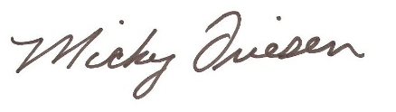
Deacon Mickey Friesen
Director

